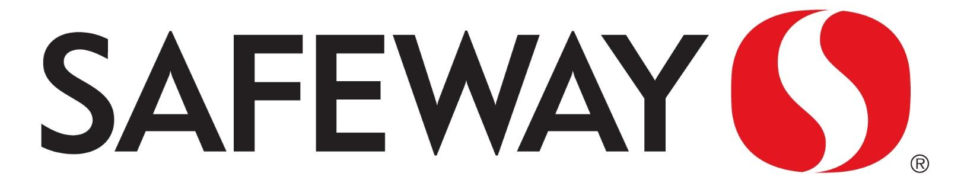
An easy way to help fill our Financial Aid Fund
Safeway Cards are available in the office (preloaded with $5).
Reload the card before you shop and 5% comes back to SMA!
You can learn more here
www.safeway.com/community-giving.html
Get Your Card Today!

An easy way to help fill our Financial Aid Fund
Safeway Cards are available in the office (preloaded with $5).
Reload the card before you shop and 5% comes back to SMA!
You can learn more here
www.safeway.com/community-giving.html
Get Your Card Today!

